“Dedicated to Serving Youth and Families in the Community”

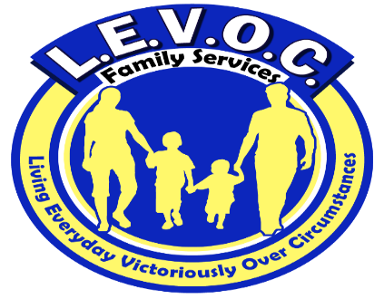

L.E.V.O.C. Family Services location

3210 Academy Avenue

Portsmouth, VA 23703

**Phone** 7557-337-0689

**Fax** 1-866-719-9383

**www.levocfs.com**

L.E.V.O.C. FAMILY SERVICES coordinates its services with other community agencies that include but are not limited to:

* Local Community Services Boards
* Departments of Social Services
* Juvenile & Domestic Court Systems
* Public School Systems
* Child Service Agencies
* Local Probation & Parole Offices

Adult services L.E.V.O.C. offers include mental health skill-building services, psychosocial rehabilitation services, and substance abuse counseling.

FUNDING FOR SERVICES

* Virginia Medicaid/Magellan
* FAMIS
* CSA
* Self-Pay

Enter Contact Information Here | 1127 Lombard Blvd. San Francisco, CA 59802 | phone 555.555.5555 | fax 555.555.5555

s

l.e.v.o.c.’s sERVICE AREAS INCLUDE:

Chesapeake

Emporia

Franklin

Hampton

Isle of Wight

Newport News

Norfolk

Petersburg

Portsmouth

Richmond

Suffolk

Southampton County

Surry

Virginia Beach

Therapeutic Day Treatment Services

TDT

Therapeutic Day Treatment services are for children and adolescents who have mental, emotional, or behavioral disorders that impair their ability to succeed in academic settings. These services involve psychotherapeutic interventions designed to develop pro-social skills and modify maladaptive behaviors.

Services

L.E.V.O.C. FAMILY SERVICES (LFS)

**L**.E.V.O.C. Family Services provides community-based services in the Commonwealth of Virginia. These services are comprehensive in nature and practical in their approach.

**E**ach client receives a comprehensive assessment and strengths-based, individualized, service plan that addresses his or her needs.

**V**ested in the communities it serves, L.E.V.O.C. works collaboratively with other community agencies and links clients to available community resources.

**O**perating in compliance with federal and state regulations governing mental health services, L.E.V.O.C. maintains the confidentiality and protects the rights & privacy of the clients we serve. L.E.V.O.C. is a member of several local Human Rights Committees.

**C**aring and competent mental health professionals work diligently to help clients achieve established goals and improve their quality of life.



What is Therapeutic Day Treatment?

Therapeutic Day Treatment (TDT) services are strategic interventions directed towards symptoms and behaviors that negatively impair students’ ability to learn and succeed in school. These interventions include but are not limited to education on medication management, and social, daily and interpersonal skill development and behavior modification programming. Treatment occurs in individual, group and family settings. LEVOC’s TDT program occurs during school hours and during the summer at our facility in Portsmouth.

TDT services include:

* Individual Counseling
* Group Counseling
* Family Counseling
* Care coordination with other required services
* 24-hour emergency response.

Living Everyday Victoriously Over

Circumstances

L E V O C

All Therapeutic Day Treatment Service Recipients Receive:

1. An assessment by a licensed or license-eligible Mental Health Professional
2. An individualized service plan with measurable goals to gauge progress
3. A caring counselor with experience working with troubled youths
4. A Master’s-prepared family counselor to facilitate positive family interaction
5. A safe therapeutic environment to learn
6. Opportunities to participate in their treatment
7. Support and encouragement to achieve therapeutic goals