L.E.V.O.C. FAMILY SERVICES coordinates its services with other community agencies that include but are not limited to:

* Local Community Services Boards
* Departments of Social Services
* Juvenile & Domestic Court Systems
* Public School Systems
* Child Service Agencies
* Local Probation & Parole Offices

L.E.V.O.C. OFFERS EACH INDIVIDUAL**:**

**H**elp to overcome obstacles hindering their growth and success

**O**ptimism that change is possible and obtainable

**P**lan to achieve and establish goals

**E**ncouragement to never give up!

L.E.V.O.C. = HOPE

FUNDING FOR SERVICES

* Virginia Medicaid/Magellan
* FAMIS
* CSA
* Self-Pay

“Dedicated to Serving Youth and Families in the Community”

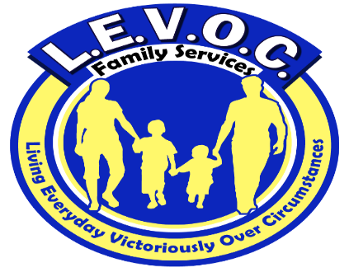

L.E.V.O.C. Family Services location

3210 Academy Avenue

Portsmouth, VA 23703

**Phone** 757-337-689

**Fax** 1-866-719-9383

**www.levocfs.com**

Enter Contact Information Here | 1127 Lombard Blvd. San Francisco, CA 59802 | phone 555.555.5555 | fax 555.555.5555

s

l.e.v.o.c.’s sERVICE AREAS INCLUDE:

Chesapeake

Emporia

Franklin

Hampton

Isle of Wight

Newport News

Norfolk

Petersburg

Portsmouth

Richmond

Suffolk

Southampton County

Surry

Virginia Beach

Mental Health Skill-Building Services

MHSS

Mental Health Skill-building Services include strategies and interventions designed to improve each individual’s level of functioning to enable them to remain stable in the community.

Services

L.E.V.O.C. FAMILY SERVICES (LFS)

**L**.E.V.O.C. Family Services provides community-based services in the Commonwealth of Virginia. These services are comprehensive in nature and practical in their approach

**E**ach client receives a comprehensive assessment and strengths-based, individualized, service plan that addresses his or her needs.

**V**ested in the communities it serves, L.E.V.O.C. works collaboratively with other community agencies and links clients to available community resources.

**O**perating in compliance with federal and state regulations governing mental health services, L.E.V.O.C. maintains the confidentiality and protects the rights & privacy of the clients we serve. L.E.V.O.C. is a member of several local Human Rights Committees.

**C**aring and competent mental health professionals work diligently to help clients achieve established goals and improve their quality of life.



Program Rules

Mental Health Skill-building Services entail goal-directed training to help individuals to achieve and maintain community stability and independence in the most appropriate, least restrictive environment. Individuals enrolled in our Mental Health Skill-building program are:

**L**inked to treatment for mental health, emotional and behavioral health issues

**E**ducated and trained in life skills to improve their levels of functioning

**V**alued and celebrated for their strengths and successes

**O**ften consulted to ensure services are satisfactory

**C**losely monitored to ensure their health and safety needs are met

Living Everyday Victoriously Over Circumstances

L E V O C

All MHSS Individuals Receive

1. An assessment by a licensed or license-eligible Mental Health Professional
2. An individualized service plan with measurable goals to gauge progress.
3. Training in functional skills and appropriate behaviors related to the individual’s health and safety
4. Training in activities of daily living, use of community resources, assistance with medication management; and monitoring of health, nutrition, and physical condition
5. Competent service providers who work under the direction of a licensed mental health professional