“Dedicated to Serving Youth and Families in the Community”

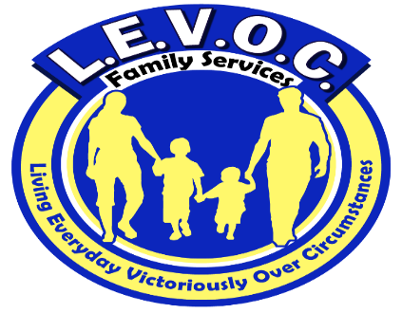

L.E.V.O.C. Family Services location

3210 Academy Avenue

Portsmouth, VA 23703

**Phone** 7557-337-0689

**Fax** 1-866-719-9383

**www.levocfs.com**

L.E.V.O.C. FAMILY SERVICES coordinates its services with other community agencies that include but are not limited to:

* Local Community Services Boards
* Departments of Social Services
* Juvenile & Domestic Court Systems
* Public School Systems
* Child Service Agencies
* Local Probation & Parole Offices

Adult services L.E.V.O.C. offers include mental health skill-building services, psychosocial rehabilitation services, and substance abuse counseling.

FUNDING FOR SERVICES

* Virginia Medicaid/Magellan
* FAMIS
* CSA
* Self-Pay

Enter Contact Information Here | 1127 Lombard Blvd. San Francisco, CA 59802 | phone 555.555.5555 | fax 555.555.5555

s

l.e.v.o.c.’s sERVICE AREAS INCLUDE:

Chesapeake

Emporia

Franklin

Hampton

Isle of Wight

Newport News

Norfolk

Petersburg

Portsmouth

Richmond

Suffolk

Southampton County

Surry

Virginia Beach

Intensive-In-Home Counseling Services

IIH

Intensive-in-Home counseling services are for children and adolescents who are at risk of removal from their homes due to severe mental, emotional, or behavioral disorders. These services involve intense interventions designed to reduce at-risk behaviors to help the child remain stabilized in the home and community.

Services

L.E.V.O.C. FAMILY SERVICES (LFS)

**L**.E.V.O.C. Family Services provides community-based services in the Commonwealth of Virginia. These services are comprehensive in nature and practical in their approach.

**E**ach client receives a comprehensive assessment and strengths-based, individualized, service plan that addresses his or her needs.

**V**ested in the communities it serves, L.E.V.O.C. works collaboratively with other community agencies and links clients to available community resources.

**O**perating in compliance with federal and state regulations governing mental health services, L.E.V.O.C. maintains the confidentiality and protects the rights & privacy of the clients we serve. L.E.V.O.C. is a member of several local Human Rights Committees.

**C**aring and competent mental health professionals work diligently to help clients achieve established goals and improve their quality of life.



What are Intensive-in-Home Services?

Intensive-in-Home Services are intensive, time-limited, interventions provided to children and adolescents who are at risk of being moved into an out-of-home placement, or who are being transitioned to home from out-of-home placement due to documented clinical needs of the child. An out-of-home placement location may include psychiatric hospital, juvenile detention center or a residential facility

Intensive-in-Home services include:

* Crisis treatment
* Individual and family counseling
* Communication skills training
* Training in problem-solving, anger management, and interpersonal interactions
* Care coordination with other required services
* 24-hour emergency response.

Living Everyday Victoriously Over

Circumstances

L E V O C

All Intensive-In-Home Service Recipients Receive:

1. An assessment by a licensed or license-eligible Mental Health Professional
2. An individualized service plan with measurable goals to gauge progress
3. A caring counselor with experience working with troubled youths
4. A Master’s-prepared family counselor to facilitate positive family interaction
5. A safe therapeutic environment to process grief, trauma and loss
6. Opportunities to participate in their treatment
7. Support and encouragement to achieve therapeutic goals